**Test Cases:**

1. What happens to the client when it cannot to connect to the server at the requested address?

Expected: A client after trying to connect to the requested server will display: ‘Unable to connect to server at localhost’. (In this example, ‘localhost’ is the requested server address.)

Actual:

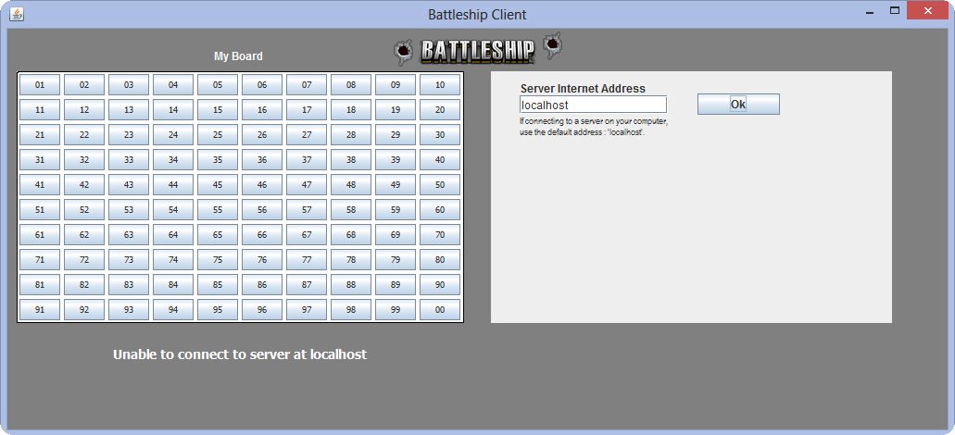

Result: **PASS**

2. Once the client(s) have connected to the server, what happens if the server disconnects?

Expected: The client displays: ‘Battleship Server disconnected’.

Actual:

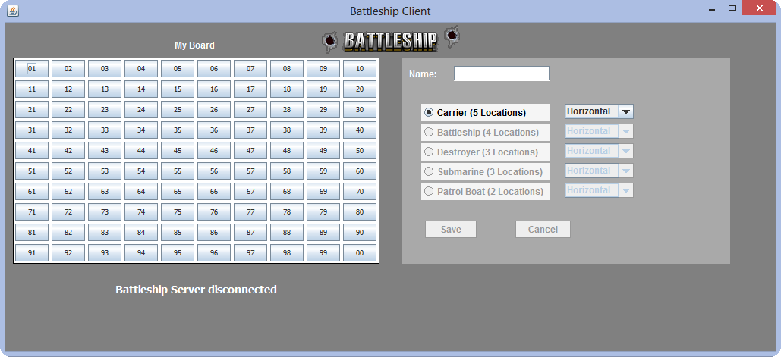

Result: PASS

3. Once the server and client are running, what happens if the client enters an invalid server internet address?

Expected: A message will tell the client that the address entered was not able to connect and will display: ‘Unable to connect to server at xxxxx.xxx’.

Actual:

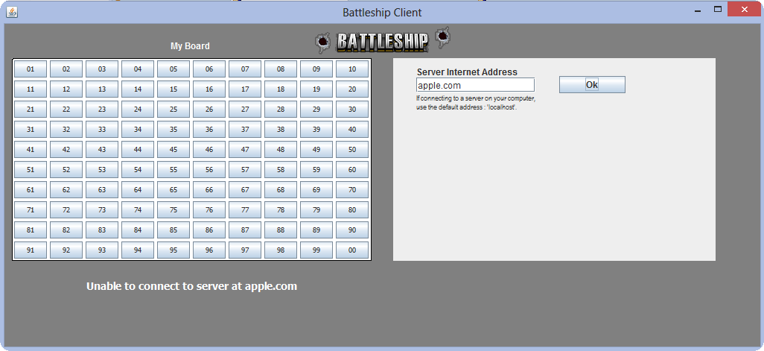

Result: PASS

4. What happens to a user’s display when their opponent disconnects?

Expected: The user’s display will show: ‘Opponent disconnected’ and no further play can happen.

Actual:

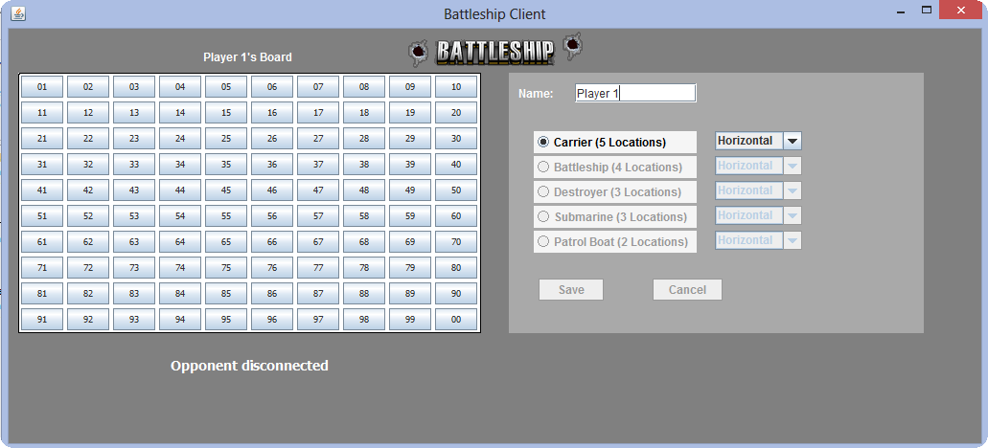

Result: PASS

5. What happens if the user tries to place a ship whose length exceeds the boundaries of the board? (In this example the user is attempting to place a horizontal carrier at location 97)

Expected: An error message on the client will display: ‘Invalid Ship Location’

Actual:

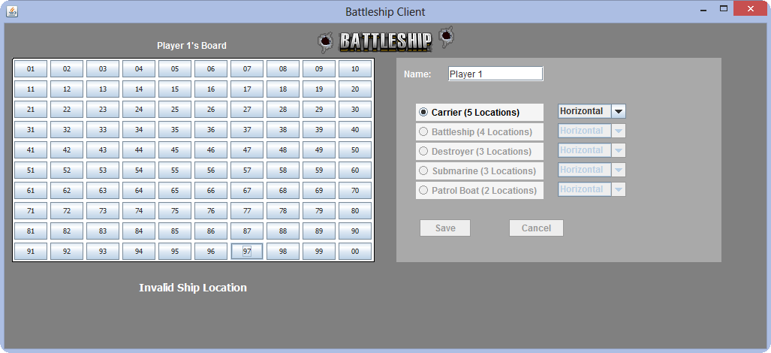

Result: PASS

6. What happens if the user tries to place a ship whose length conflicts with the placement of an already placed ship? (In this example the user is attempting to place a horizontal destroyer at location 95)

Expected: An error message on the client will display: ‘Invalid Ship Location’

Actual:

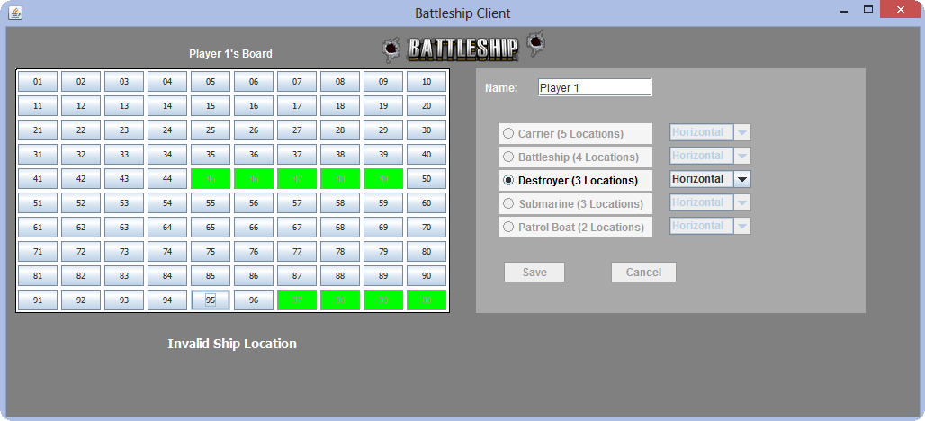

Result: PASS

7. What happens once to a player who tries to fire, but it is not their turn? (In this example it is Player 1’s turn, however Player 2 tries to fire at Player 1’s board at location 91)

Expected: No change in the display.

Actual:

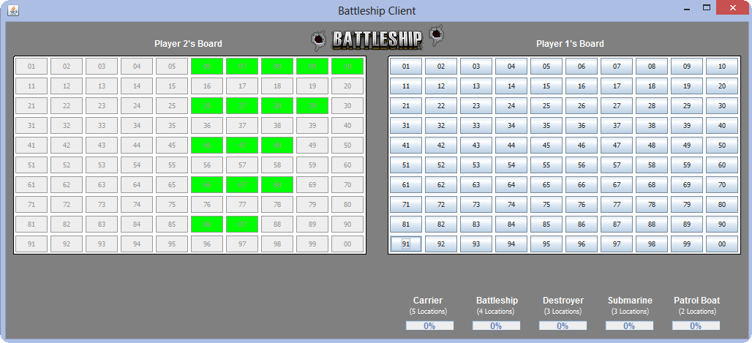

Result: PASS

8. What happens when a player fires at a location that contains the other player’s ship?

Expected: (In this example Player 1 fired at Player 2’s board location 06 which has a carrier ship) For Player 1, the fired location color changes from grey to red to indicate a ‘hit’, and the progress bar of the respective ship is updated to show that more of that particular ship is considered sunk. For Player 2, the board that shows the placement of their ships will indicate a ‘hit’ at the fired at location.

Actual:

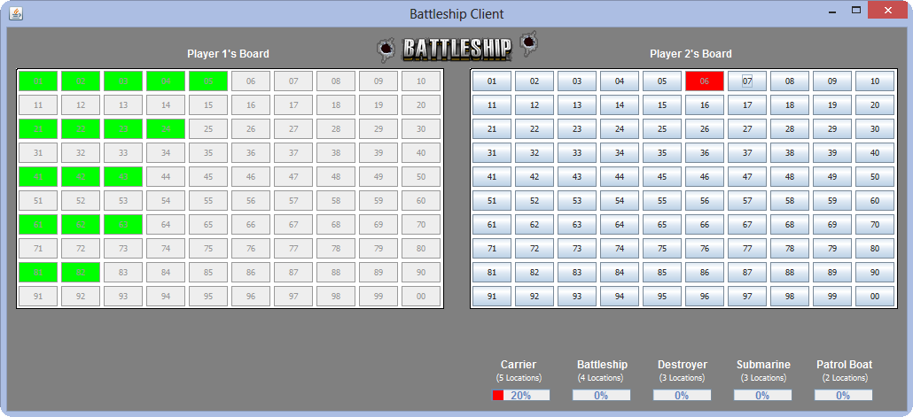

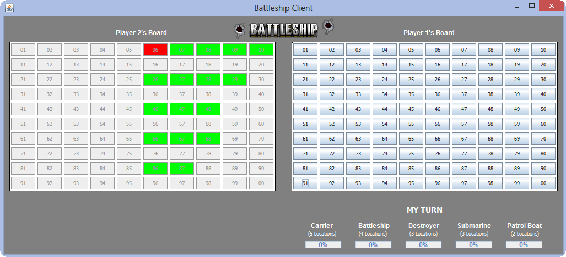

Result: PASS

9. What happens when all ships from a single user have been sunk? (In this example Player 1 has fired at and ‘hit’ all of Player 2’s ships)

Expected: The game will display a message to both users to inform them who won. The game ends.

Actual:

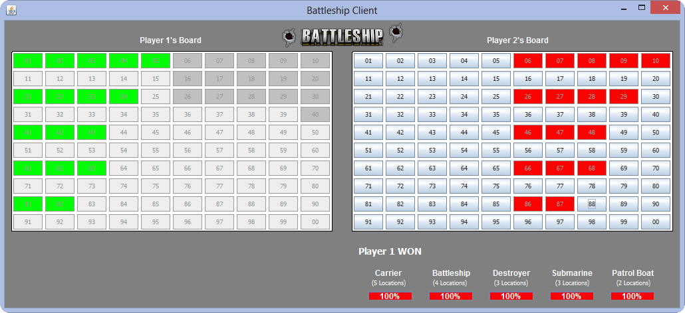

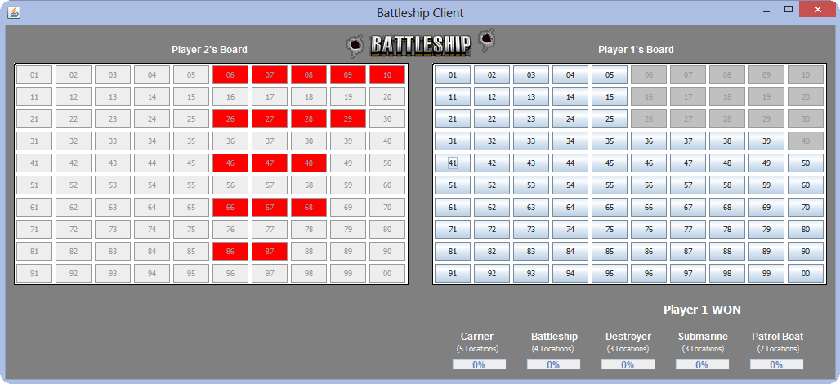

Result: PASS

10. What happens when once a winner has been announced and either player tries to continue playing? (In this example user 1 is the winner, and tries to continue play by firing at location 91)

Expected: No display change. The game has already ended.

Actual:

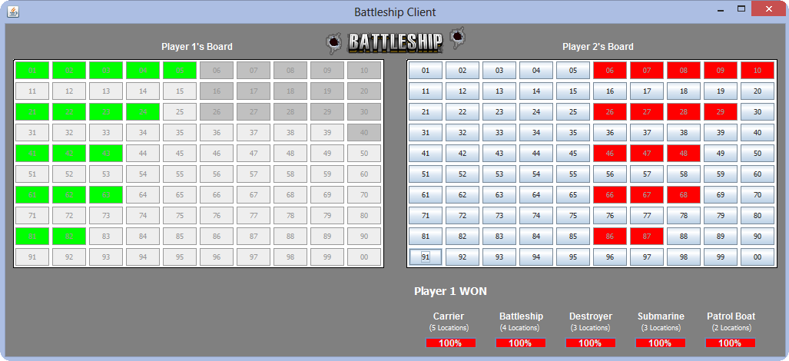

Result: PASS